

SOUTH EASTERN UNIVERSITY OF SRI LANKA FACULTY OF MANAGEMENT AND COMMERCE

B.Sc. in Management and information Technology

MIT 22043 – Web Application Development

INDIVIDUAL PROJECT REPORT

***computer services***



**Table of Contents**

1. **Introduction…………………………………………………………………………….…1**
2. **Site map……………………………………………...…………………………………….1**
3. **Utilized Technologies………………………………………………………………....…..1**

**03.01 Frontend development………………………………………………………………...2**

**03.01.ⅰHTML…………………………………………………………………………......2**

### 03.01. ii CSS…………………………………………………………………………….…3

### 03.01. ⅲ JS………………………………………………………………………………4

## 03.02 Backend development………………………………………………………………....4

## 03.02.ⅰPHP……………………………………………………………………………..4

### 

# 01 Introduction

# Today, technology is an essential factor of the entire community and thus computers are widely used. Get a glimpse of our commitment to quality and how we can help you with your computer-related needs. Explore our wide range of services designed to optimize your technology experience.

# Site Map

* My Web site name **B C Tech.**
* My web application have 5 web pages, it is the **HOME,SERVICES,CONTACT,FEEDBACK,ABOUT**
* **Home** page is the main index page it is in Navigation bar link and connect with each other all pages
* **SERVICES** In this page we can see our service providers and service availability time
* **CONTACT** From this page you can find out more information about the services and how to contact the service providers.
* **FEEDBACK** This page includes feedback from service users

1. **Utilized Technologies**

To develop a digital presence that makes ideas come to life, careful technology fusion is needed. In this document, the primary web development technologies are reviewed. From the foundational HTML, CSS, and JS that provide structure and design to JavaScript's dynamic features that enhance user interaction, we progress through the coding languages that form the digital world. MySQL and other server-side technologies, like PHP, are essential to data administration. Come along as we analyze the technological web that facilitates the creation of effective websites.

* To design this website, I'm utilizing both front-end and back-end programming.
* I used HTML, CSS, and JS for front-end development.
* I utilized the PHP and MySQL technologies for backend development.

## Frontend development

### HTML provides structure, CSS adds style, and JavaScript adds interactivity to websites through innovative fusion of these frontend technologies. This innovative team creates captivating digital experiences from static web pages. Come learn about the creative ways that HTML, CSS, and JavaScript mix to produce visually appealing and engaging websites.HTML

### 03.01.ⅰHTML

* All web pages are creating to use the HTML.
* 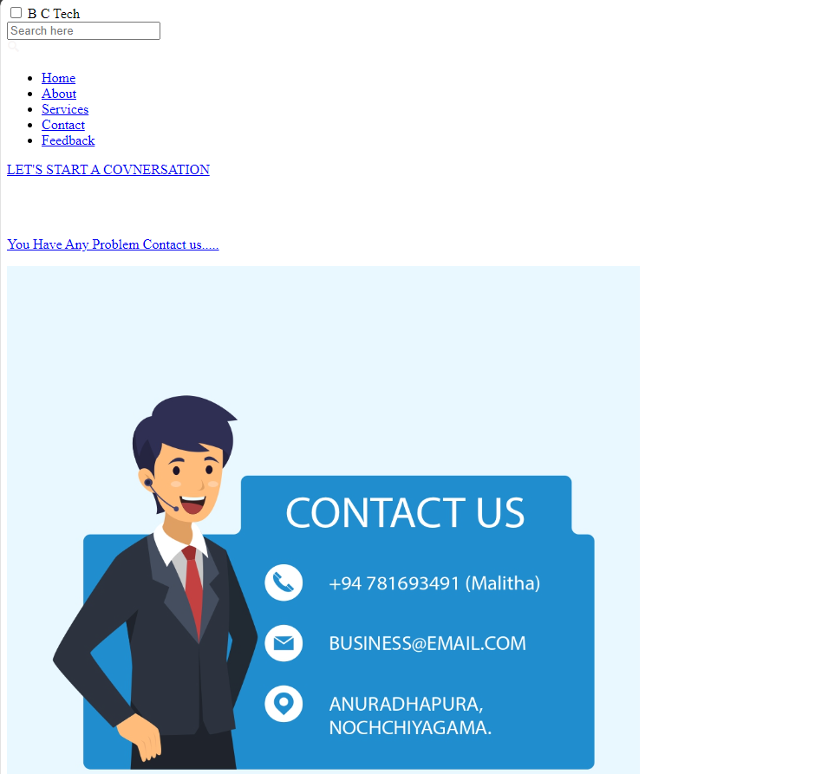 a, i, img, body, p, form, input, h etc. like many Html tags I used to create web pages.

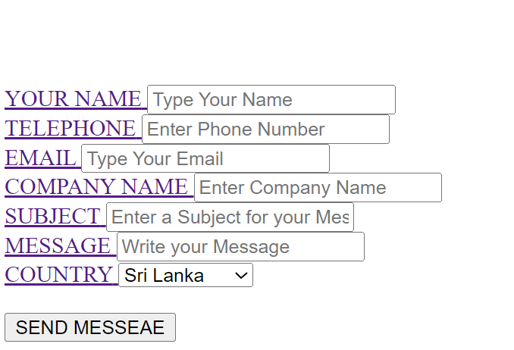

***Figure 1 HTML using web site***

### ii CSS

* + - All web pages are creating to use the CSS.
    - 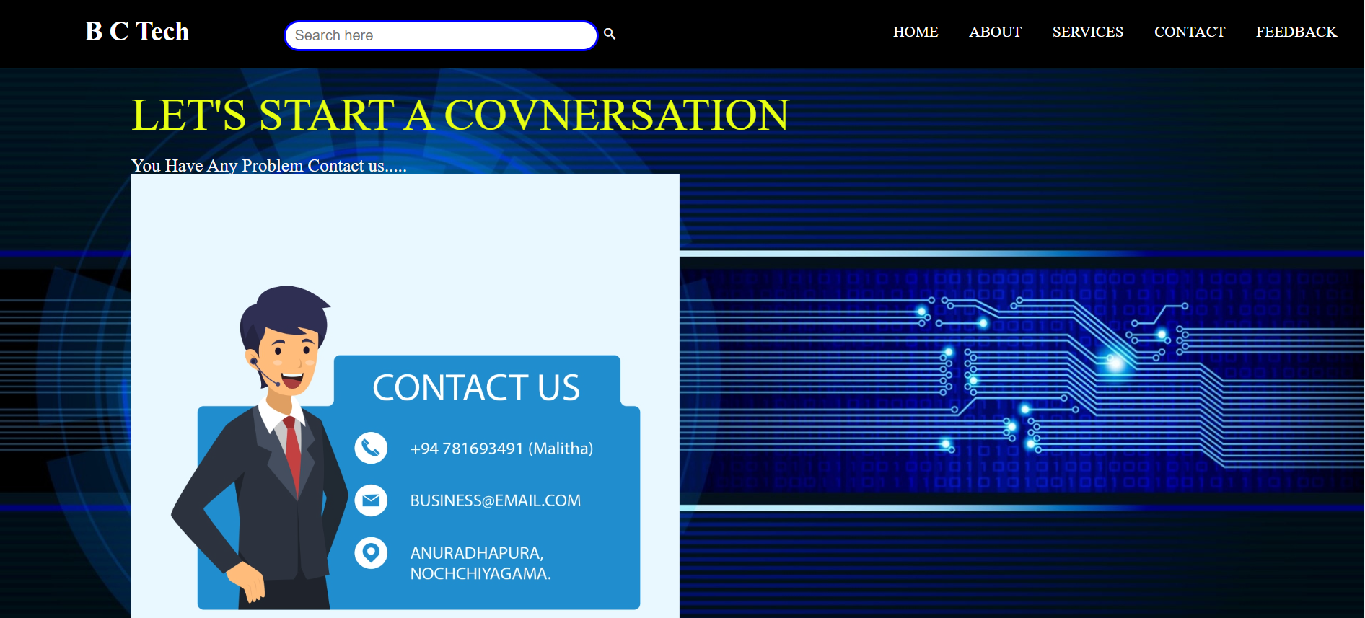Background, Transition , hover, blur, Color, font style, Key frames etc. like many CSS attributes I used to create web pages

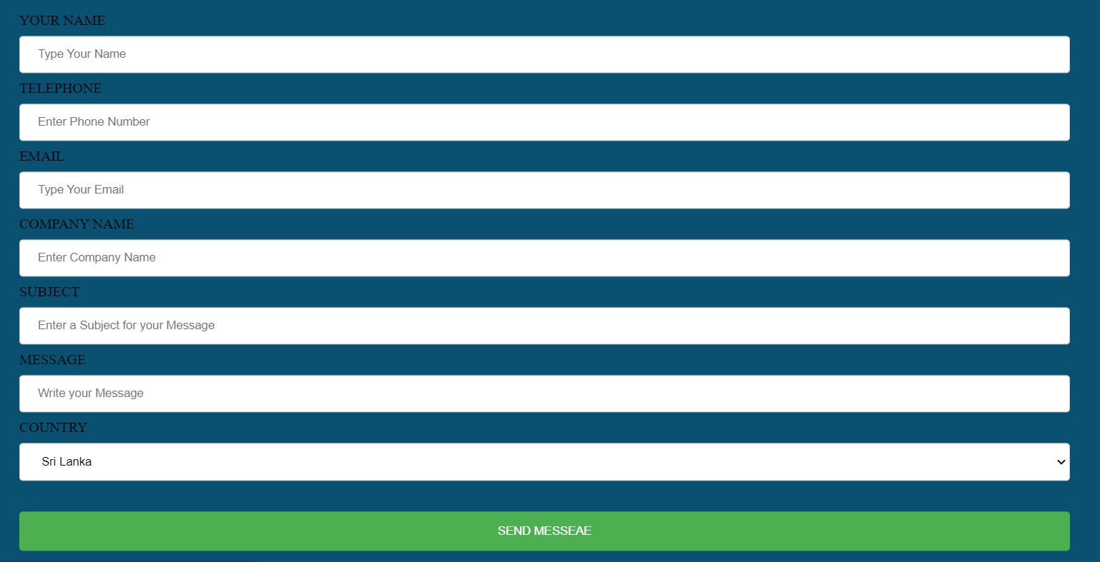

***Figure 2 CSS using web site***

**03.01.ⅲ JS**

* I used JavaScript create to the welcome massage box when entering web site

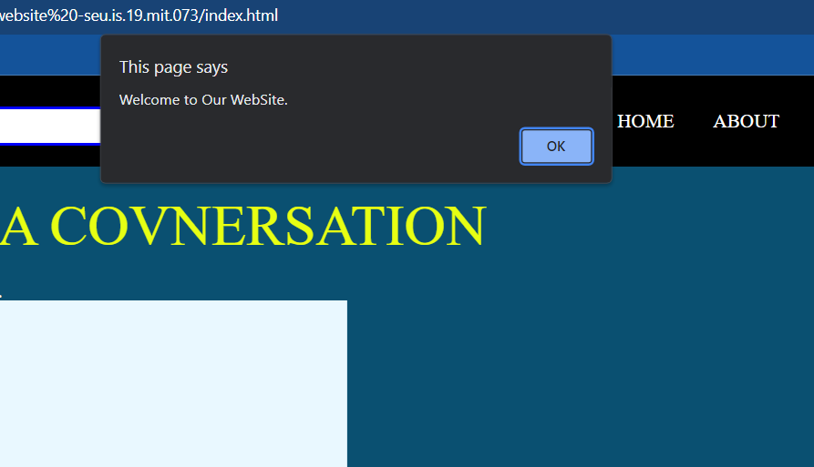

***Figure 3 JS using web site***

## Backend development

### Backend development powers websites by creating flawless digital experiences. It ensures dynamic and effective functionality by managing databases, processing data, and executing logic using languages like PHP.

### PHP is the backend engine that drives web development and is also a powerful language. PHP's flexibility makes it simple to integrate databases, handle data, and apply logic. It is the cornerstone of dependable and scalable web applications, ensuring a responsive and dynamic online experience from user authentication to dynamic content delivery.PHP

### 03.02.ⅰPHP

* I used to php create the **Database** get the user account information and store it.
* 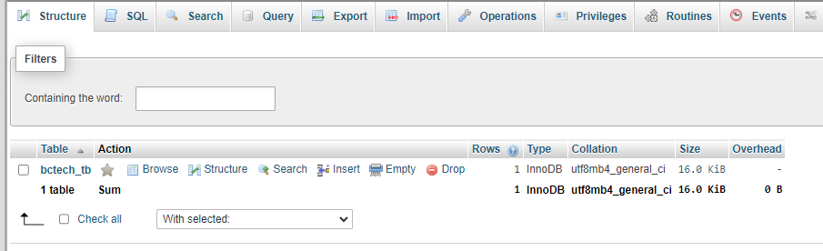Create **B C Tech db** database and **registration_tb** table store to user account information.

***Figure 4 “*B C Tech*” database***

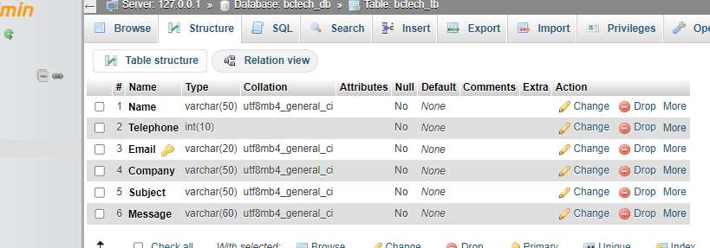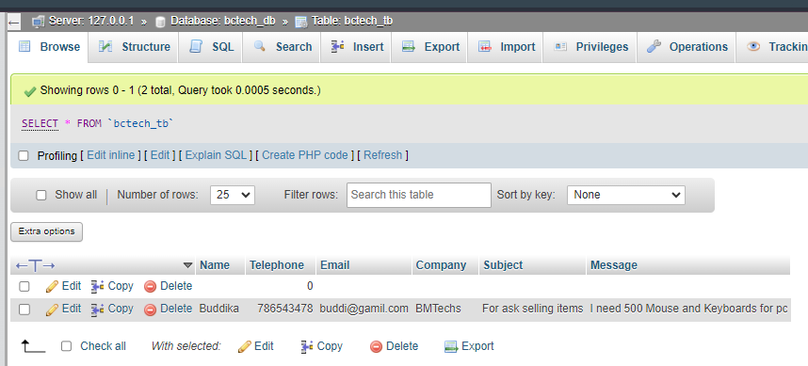

***Figure 5 “*registration_tb*” table***

* User details fill and submit

**.**



***Figure 6 user details submit page***

* user give incorrect details its show user to **Alert**

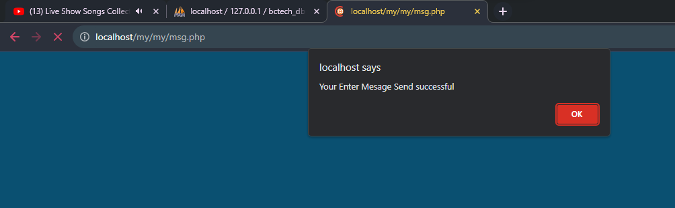

***Figure 7 view user Alert***